Wild Game Processing  Processing of Deer, Antelope, Mule, Bear & Whole Deer $110.00  Processing of Elk, Moose & Caribou $1.00 lb.  Grinding of Wild Meats $1.00 lb.  Pork added $2.59 lb.  Beef added $3.99 lb.  Processing quarter $20.00 quarter  Cryvaking per bag .40 bag  Cape out charge $35.00  Making of Wild Game Sausage  Summer Sausage $75.25  Bologna $72.25  Polish (fresh or smoked) $72.25  Breakfast sausage Bulk $72.25  Kielbasa (fresh or smoked) $72.25  Brats (fresh or smoked) $72.25  Hot sticks- All $97.25  Wieners $97.25  Breakfast Links $97.25  Jerky Ground $5.95  Jerky Strips $6.95  Bacon $87.25  Cheese added to Sausage $10.00  Smoking of Wild Game $1.00 lb.  16 lbs. of Wild Game Needed Per Batch and we add 9 lbs. of pork Total Raw Weight = 25 lbs. |  |  | Custom Processing of Beef, Pork and Lamb  Beef Slaughter $70.00  Pork Slaughter $40.00  Lamb Slaughter $40.00  Processing charge .70 lb.  Hamburger patties (30 lb. Min) .85 lb.  Smoking charge $1.00 lb.  Slicing charge $1.00 lb.  Sausage  (Made from your custom Processing)  (All your meat)  All process per batch (25 lbs per batch)  Summer $42.75  Bologna $50.75  Brats $44.75  Polish $50.75  Kielbasa $50.75  Hot Sticks- All $67.95  Wieners $77.75  Breakfast Links $61.75  Jerky Ground $5.95  Jerky Strips $6.95  All Prices Per Batch (25 lbs. per batch)  fedfsdf |  |  | Your Full- Service  Meat Market  6811 Bur Oak Rd  P.O. Box 659  Stevens Point, WI 54482  715-592-6328  Visit us at: www.peoplesmeatmarket.com  Mon- Fri: 8 to 5:30  Sat: 8 to 3  Sun: Closed  * All Prices Subject to change  - * All Prices Subject to change

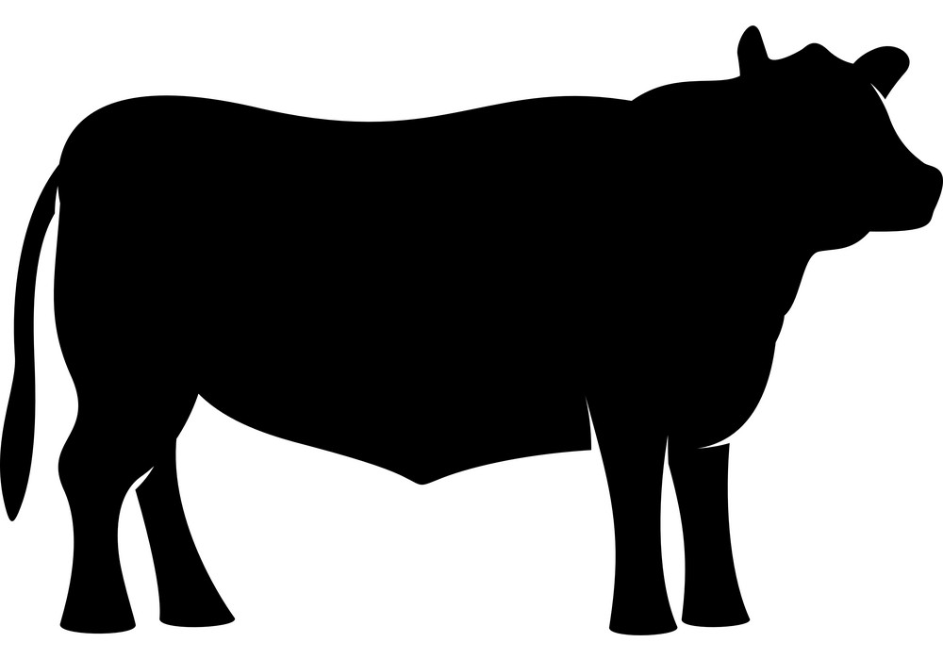  Beef Bundle  $79.99 for 25 lbs. of Meat  - Roast  - Round Steak  - Hamburger  - Hamburger Patties  - Stew Meat  - Whole Chicken |  |  | “Local Grown”  Black Angus Beef & All Natural Pork  Whole Beef $2.85lb.  Half Beef $2.90 lb.  Quarter Beef- Mix $2.95 lb.  Whole Pig $2.30lb.  Half Pig $2.35 lb.  Includes:  Cutting, Wrapping, Freezing and Boxing  Slaughter & Smoking: Extra Charge  Based on Market Price  Summer Grilling Specials  10 lb. box of Beef Patties  $3.99 lb.  25 count Pre-cooked Brats  $3.89 lb.  All Prices Subject to change  We ask that you pick up your orders within 3 days after being called and after two weeks we will charge a $10 storage fee per week.  “Don’t be shy! Show them how fabulous you are! This is a great spot for a glowing testimonial.”  Get the exact results you want  To easily customize the look of this brochure, on the Design tab of the ribbon, check out the Themes, Colors, and Fonts galleries.  Have company-branded colors or fonts?  No problem! The Themes, Colors, and Fonts galleries give you the option to add your own. |  |  | 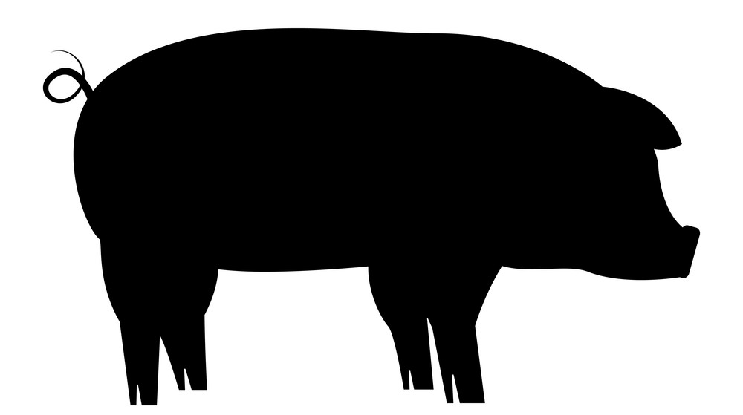  Pork Bundle  $54.99 for 30 lbs. of Meat  - Chops  - Steaks  - Roast  - Pork Sausage  - 2 packages – Your Choice of Pork Brats

